**Fakebook – Startup Guide**

* "Fakebook" is a free tool at [www.classtools.net](http://www.classtools.net) which we will use to create a “Fake Facebook” page for your business.
* This will be a part of the social media marketing campaign for your business. You will be able to use many of the items that you have created in Canva.
* Follow the directions in the assignment sheet that goes with this assignment.

• You can save your work and edit it again later.

**Starting Up:**

**1. Enter the name of your business**

An image will automatically appear. Click on this if you would rather change it to an image uploaded from your computer.

**2. Add Your Facebook cover image that you created**

**3. Add Your Logo that you created**

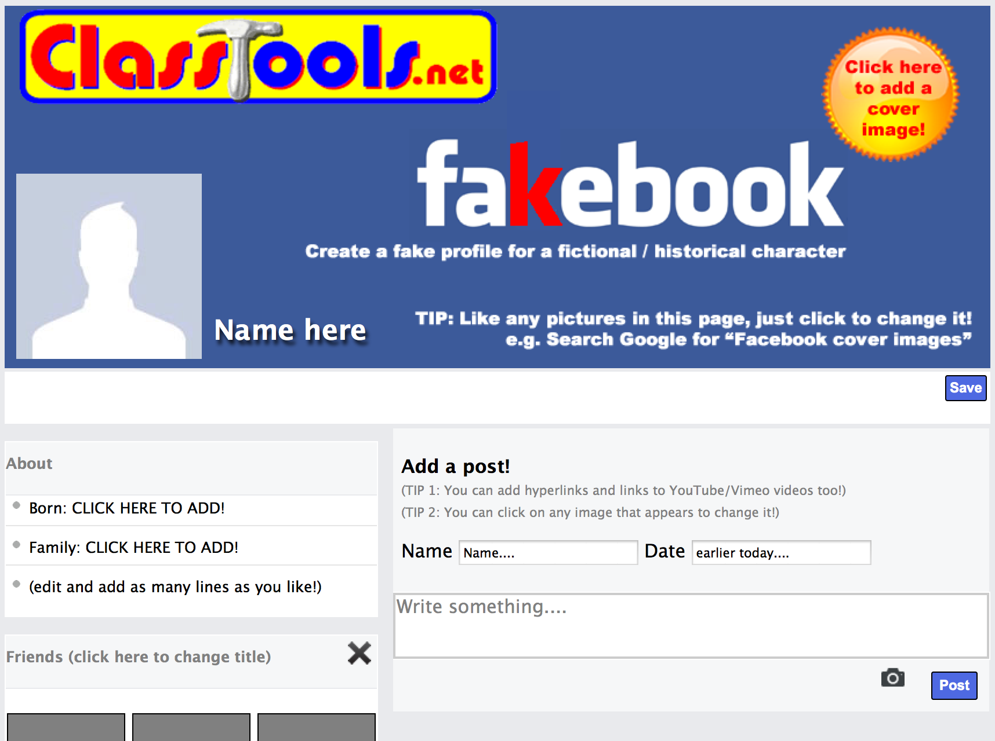

**3. Add some key information**

**about your business in the ‘About’ box**.

**4. Start adding some “Friends” in the first block**

You can add as many of these blocks as you like – for example, add another for ‘hobbies’, ‘likes, ‘hates, ‘places visited, ‘favorite books’ and so on. An image automatically loads. You can click any image to change it.

**5. Add a post. Just provide a name, a date, and write something**

You can add hyperlinks and links to YouTube/Vimeo videos too. Just copy and paste the URL’s in the post. An image automatically loads. You can click any image to change it. If the image you want doesn’t show up just click it and select your new image.

**6. Add a comment and / or a ‘liked by…’ after the post appears**

Like the posts, comments can be ‘dragged and dropped’ with your mouse.

**7. Need to add more blocks? Click “Add New Block”**

**8. Don’t forget to save your page!**

You will be prompted to **create a password** for this. Use one that you will not forget. You will need this when you want to edit your page or make more posts.

**9. Copy the URL address or share it with your email**

You can easily pull your page up to edit it.

**10. Edit your page**

Click anywhere on it. Type your password in and you are ready to go.